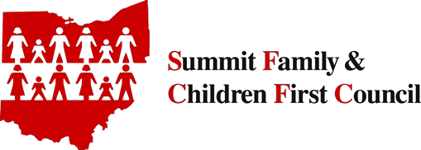
The Summit County
Family and Children First Council
is looking for
Youth and Young Adult Representatives!

COULD THAT BE YOU?!

Who We Are

We are a partnership of local governmental entities, community agencies, youth and families.
What We Do
We look for ways our community can work together to improve services offered to Summit County youth and families.
When and Where We Meet
We meet the first Thursday of every odd numbered month (i.e. January, March, May, July, September , November), 10:30 – Noon, at the Summit County Health Department.
Youth/Young Adult Representation
We value the voice of youth, young adults and families. Our By-Laws allow for two (2) youth/young adults to serve on its General Membership. You would get to vote!
Youth/Young Adult Representative Qualifications
- Utilization of services (either current or past use) from one of the agencies represented on the Council (see attached membership list)
- Under the age of 26 years
- Not employed by an agency represented on the Council
- An interest in creating a community where children and families thrive
Commitments/Expectations
- Attend at least 5 out of the 6 General Membership meetings each year.
- Serve at least a 1 year term. Terms of service begin January 1st and end December 31st. Terms are renewable without limit until reaching the age of 26 years
- Speak up! Your voice matters. Youth/young adult representatives are asked to speak on behalf of other youth/young adults and promote youth friendly policies and programs

Compensation
Youth/young adults receive a stipend of $35 for attending Council meetings
Interested in Applying?
If you are interested in this opportunity, please provide a 1-2 page letter that shares the following information:
- Full legal name
- Age
- The agency(s) represented on the Board from which you are receiving or have received services
- Leadership experience (not required)
- Short narrative explaining why you want to serve in this role
Letters should be submitted by to:
Janice Houchins, Director
Summit County Family and Children First Council
1867 West Market St.
Akron, OH 44313
jhouchins@schd.org

Thank you for your consideration of this opportunity.

Please contact Janice Houchins at 330-296-5671 with any questions.

