The University of Akron
The BOD POD
What is the BOD POD?
The BOD POD estimates lean muscle mass and the percentage of body fat, providing a more accurate weight of an individual. This egg-shaped pod uses air displacement to measure the body’s density within a 2% margin of error.
The BOD POD’s roomy interior accommodates a wide variety of human shapes and sizes. That is why it is used routinely to measure the body composition of professional and collegiate football players, basketball players, and even sumo wrestlers! The BOD POD has successfully been used by people weighing up to 500 lbs. It's also ideally suited for wheelchair athletes, those with special abilities, the elderly, and children. And, because the BOD POD is noninvasive, it is completely safe for regular and repeated testing.
Why choose the BOD POD for body composition analysis?
- Proven Accuracy using whole-body density measurement.
- Fast test time – about 5 minutes.
- Ability to accommodate all types of populations (including children, the elderly, and the disabled).
- Excellent repeatability. Safe for repeated testing and is non-invasive.
The University of Akron offers BOD POD testing:
Community: $25 per test
Faculty/Staff: $20 per test
Students: $15 per test
Group rates and multiple test packages are available
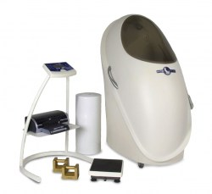
Call (330) 972-2334 to schedule an appointment.

